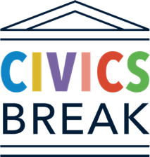

FACILITATOR’S COURSE GUIDE

Civics Break:
Civics Education About the Judiciary

Thank you for your interest in Civics Break, a civics education course designed for the workplace. The course is designed to give learners of all backgrounds a better understanding and appreciation for the rule of law, courts, and the judicial system in the United States. Below, we have recommended a few options on how the course can be adapted to your workplace.

About the Course Modules

The course consists of three modules and an optional Q&A session where participants can meet judges and ask their questions about the legal system. Below is a facilitator’s guide to the course modules, including descriptions of each module, discussion questions, and additional resources. Note: For self-guided learners, the discussion questions can become questions for personal reflection.

Table of Contents

About the Course Modules 1
Module 1: The Rule of Law and the Foundations of the Judiciary 1
Module 2: The Job of Judging 2
Module 3: The Courts and You 3
Module 4: Live Q&A with Judge(s) 4
Suggested Schedules 4
After Course Completion 5

Module 1: The Rule of Law and the Foundations of the Judiciary

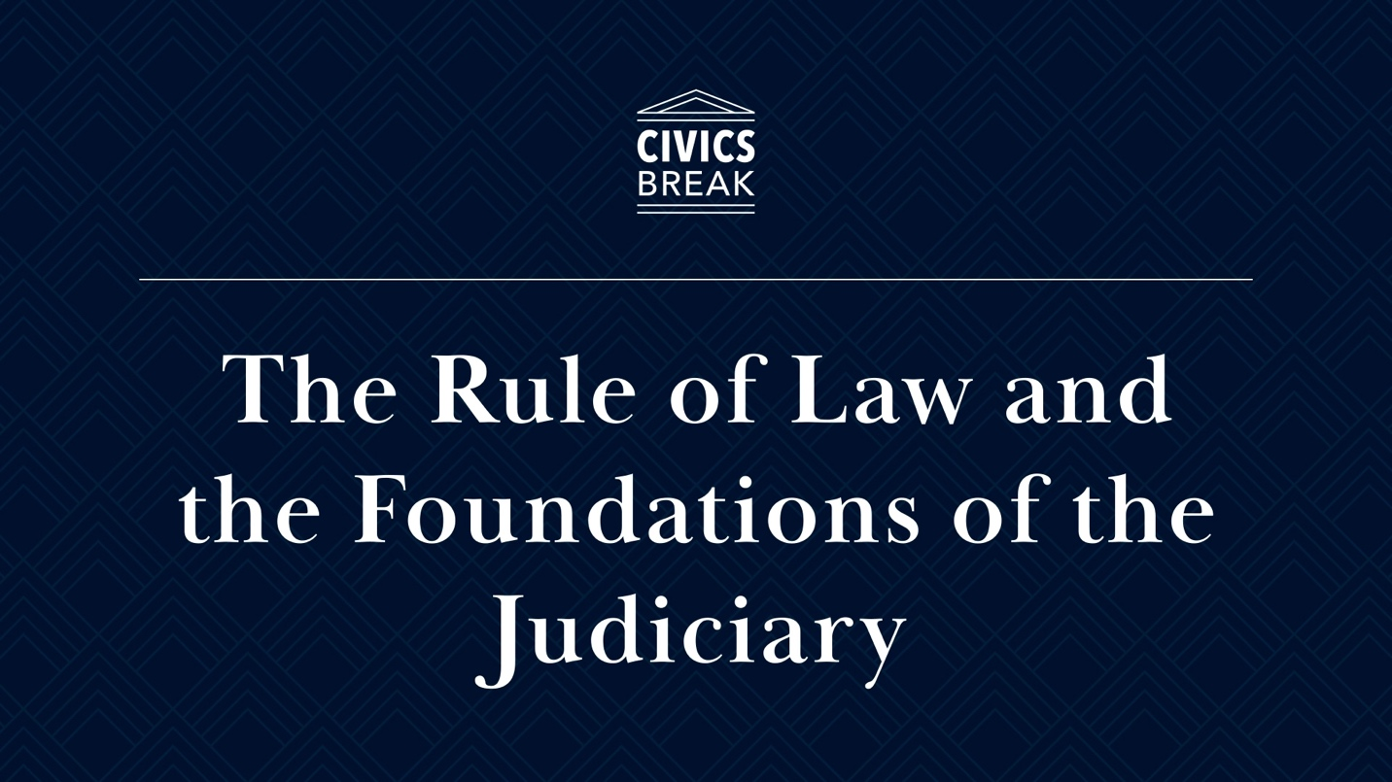

Video Link

This learning module explores the rule of law and the constitutional foundation of the U.S. judicial system. The U.S. Constitution outlines a government system that balances power among three branches of government: legislative, executive, and judicial. This module explores the powers and responsibilities of the judicial branch, how the judiciary and U.S. law have developed over time, and how state and federal courts work together to resolve disputes, protect our individual rights and liberties, and uphold the rule of law.

Discussion Question:

- What are some examples of laws that allowed you to be here, taking this course, today?

Additional Resources:

- Companion Video: Court Shorts: Rule of Law (YouTube, U.S. Courts)

Module 2: The Job of Judging
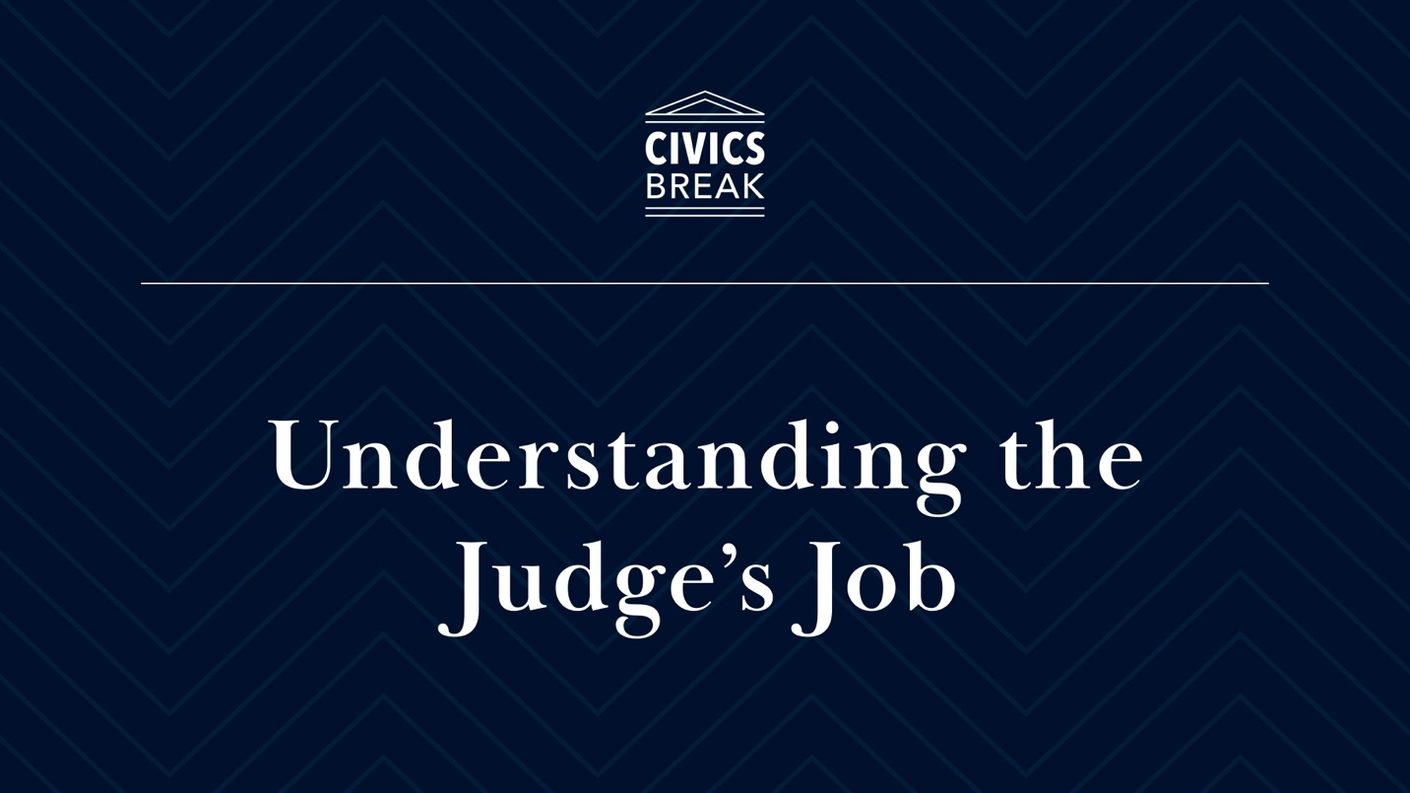

Video Link

In this module, you will learn about the roles, responsibilities, and decision-making processes of judges. This module explores the various ways federal and state judges get their jobs, what it means to be fair and impartial, and the legal principles, ethical codes, traditions, and guidelines that constrain judicial decision-making. In an accompanying exercise, participants can apply judicial decision-making skills in the hypothetical sentencing of a defendant.

Discussion Question:

- What aspects of a judge’s job would you personally find the most difficult? For example, being impartial, sentencing, being constrained by the law.
- After today’s course, what aspects of a judge’s job do you think may get exaggerated in movies and on television?

Additional Resources:

- Companion Video: Court Shorts: Fair and Impartial Judiciary (YouTube, U.S. Courts)

Module 3: The Courts and You
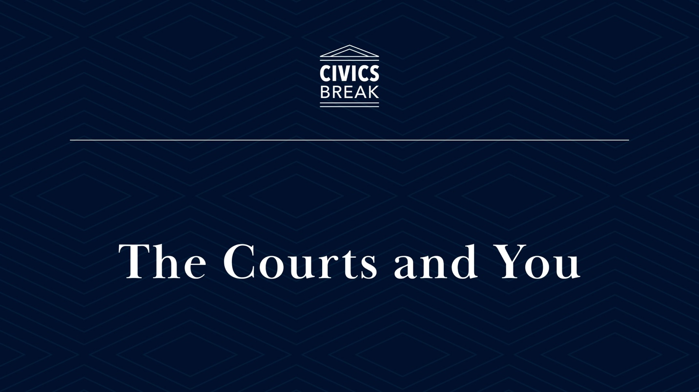

Video Link

In this learning module, you will learn about the vital role of citizens in supporting and engaging with the judicial system. We’ll explore the various types of jury service, opportunities to voice support for reform and change in the courts, and how to become an educated consumer of news and information about judges and courts. From serving as a juror to voting to sharing accurate news, American citizens have the right and responsibility to engage with the courts and ensure that the judicial branch fulfills its constitutional obligations.

Discussion Questions:

- Think about a positive interaction you’ve had with a government agency. What made that interaction positive?
- What is a recent example of misinformation or disinformation that you have encountered online? What clues led you to understanding that the information was false?

Additional Resources:

- Companion Video: Court Shorts: Jury Service, Hands-on Justice (U.S. Courts)
- Companion Video: Judicial Independence Jury and Outreach (NAWJ)

Module 4: Live Q&A with Judge(s)

In this session, participants will talk directly with a federal judge and/or a state judge. Sitting judges cannot respond to questions about cases or issues that might come before them, but they can speak in general terms about the work they do and the structure and role of the courts. This session provides the rare opportunity to ask a judge about their jobs, why they do it, the challenges they face, and what they think citizens should know about judging, the courts, and the rule of law. If you are interested in scheduling a conversation with a judge, email us at bolchjudicialinstitute@law.duke.edu.

Suggested Schedules

The course is designed to be short and flexible to adapt to many different workplace scenarios. The total run-time for all three videos is just under one hour. However, we recommend allowing time between each video to avoid “cognitive overload,” and this is especially helpful if the course is being offered in a group setting to allow plenty of time for discussion and reflection among participants. Below are three possible options for delivering this course at your workplace.

Civics Lunch Break

The course was designed with the lunch break in mind as the optimal time to learn about civics! Each module is scheduled for a standard 1-hour lunch break, either in-person or remote. The total instructional time for each module is about 30 minutes, which allows plenty of time for discussion, reflection, and community building among participants. If the course is being delivered in-person, we highly recommend providing lunch to boost engagement and attendance! The Civics Lunch Break can be scheduled at any interval, but we tested the course with both weekly and twice-a-week deliveries with great success!

Self-paced Civics Break

The self-paced Civics Break works great for the self-motivated learner who simply wants to learn more about the judicial system. Whether your self-employed or work from home, you’re in charge of your own Civics Break journey! We recommend turning off your phone, silencing your email, and taking a true break from your busy day. We are also exploring options to host virtual Q&A sessions for self-paced Civics Break learners. If you are interested in meeting a judge for a virtual session, please subscribe here to receive Civics Break updates.

The Extended Civics Break

The course is short enough that all three videos and discussion can be completed in under 1 hour. This may work best at work retreats, conferences, or other events to accommodate a break that is longer than 1 hour. If a Q&A session with a judge is still desired, we recommend scheduling it at a later time, so participants have time to digest the concepts presented in the course and formulate questions for the judge.

After Course Completion
Participants who complete all the Civics Break learning sessions will receive a digital certificate of completion. Self-paced learners can take this Quiz and Survey to mark the completion of the course and be entered to win a Civics Break T-shirt!

